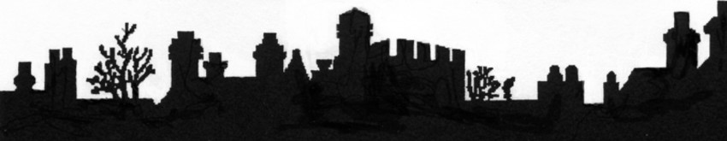

**OUNDLE HISTORICAL SOCIETY**

### PROGRAMME CHANGE

**DAVID BOND**

**OUNDLE AND THE DOMESDAY BOOK**

Friday 10th September 2021

7.30 p.m.

##### Oundle Methodist Church

Drummingwell Lane, OUNDLE

Members Free. Non-members £2

Coffee & Biscuits served.

TO JOIN OUNDLE HISTORICAL SOCIETY please visit www.oundlehistoricalsociety.org.uk

ALL WELCOME